Experiment-10
Aim : To study and implement JOIN operations and subqueries using Departments and
Employees tables.

Create Database


Table Structure
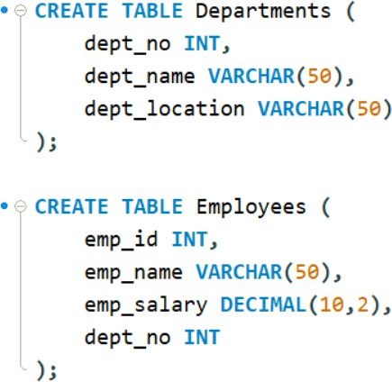

Insert Sample Data
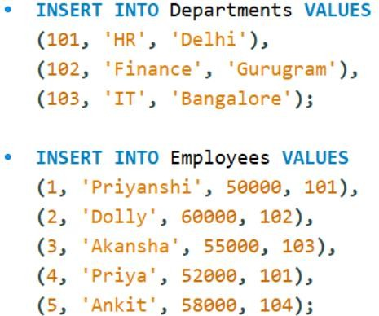

Display employee details where department matches in both tables (INNER JOIN)
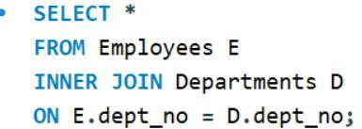

Output:
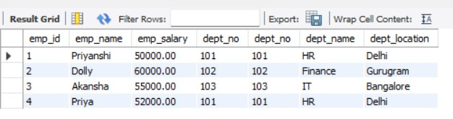

Explanation
  - INNER JOIN returns only matching records
  - Employees with valid department numbers are shown
  - Employee with dept_no = 104 will NOT appear

LEFT OUTER JOIN
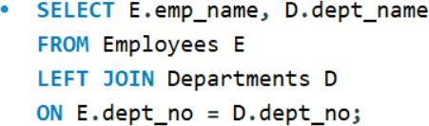

Output:
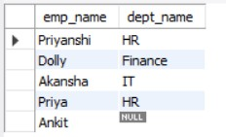

Explanation
  - Returns all employees
  - If department doesn’t exist → shows NULL
  - Example: Ankit will appear with NULL department

RIGHT OUTER JOIN
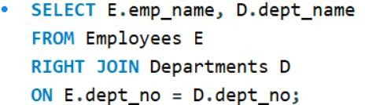

Output:
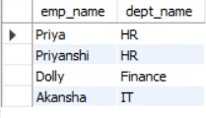

Explanation
  - Returns all departments
  - If no employee in a department → employee name will be NULL

Employees with Salary Greater than Average Salary
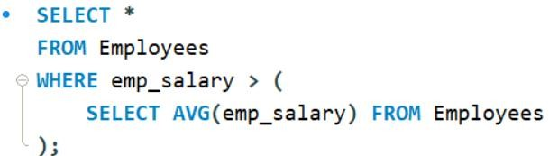

Output:
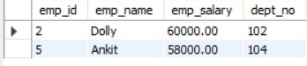

Explanation
  - Subquery calculates average salary
  - Outer query selects employees earning more than average

- Display Table
